**CRUD with Angular**

**Our Goal is to Build an Employee Details Dashboard application that should be able to provide options to add, edit and delete employee information.**

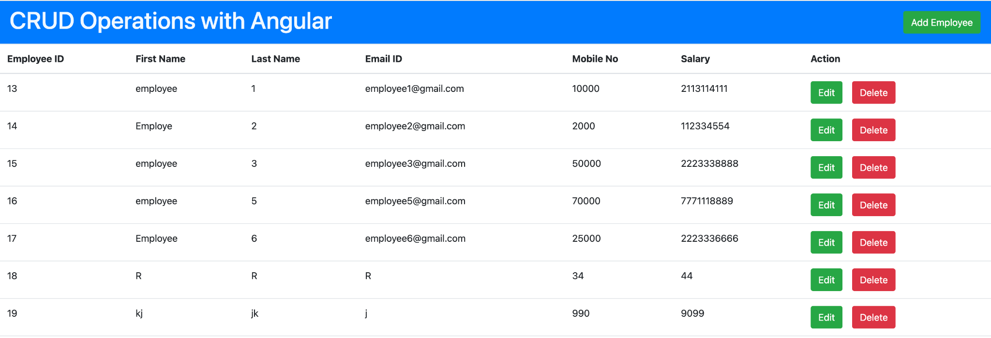

1) Node installation is required to run applications locally.

Preferred - v16.16.0

Download it from : [**https://nodejs.org/en/download/**](https://nodejs.org/en/download/)

**Note: Verify installation using command prompt or terminal by running command node -v**

2) Install Angular Cli

Command : **npm i @angular/cli**

**Note: Verify installation using command prompt or terminal by running command**

**ng - -version**

3) Create new angular app using angular cli

Command: ng new angular-app-name

4)Would you like to add Angular routing? (y/N)

Answer : y

5)Which stylesheet format would you like to use? (CSS/ SCSS/Sass/Less)

Select CSS or SCSS by using keyboard keys.

6) Create Employee dashboard

Command :

ng generate component component-name

Or

ng g c component-name

EX: ng g c emp-dashboard --skip-tests

The above command will create a brand new folder with emp-dashboard under app folder.

Find the Changes below.

CREATE src/app/emp-dashboard/emp-dashboard.component.scss (0 bytes)

CREATE src/app/emp-dashboard/emp-dashboard.component.html (28 bytes)

CREATE src/app/emp-dashboard/emp-dashboard.component.ts (303 bytes)

UPDATE src/app/app.module.ts (501 bytes)

7) Set Default route as an Emp-dashboard.

Add new route to Routes array in the app-routing.module.ts

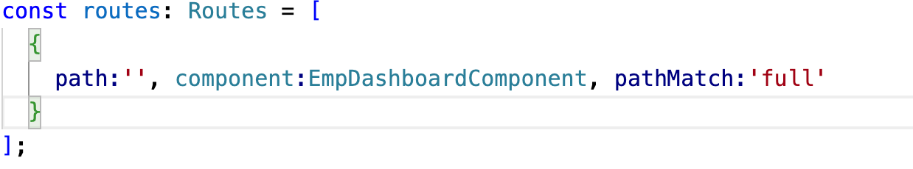

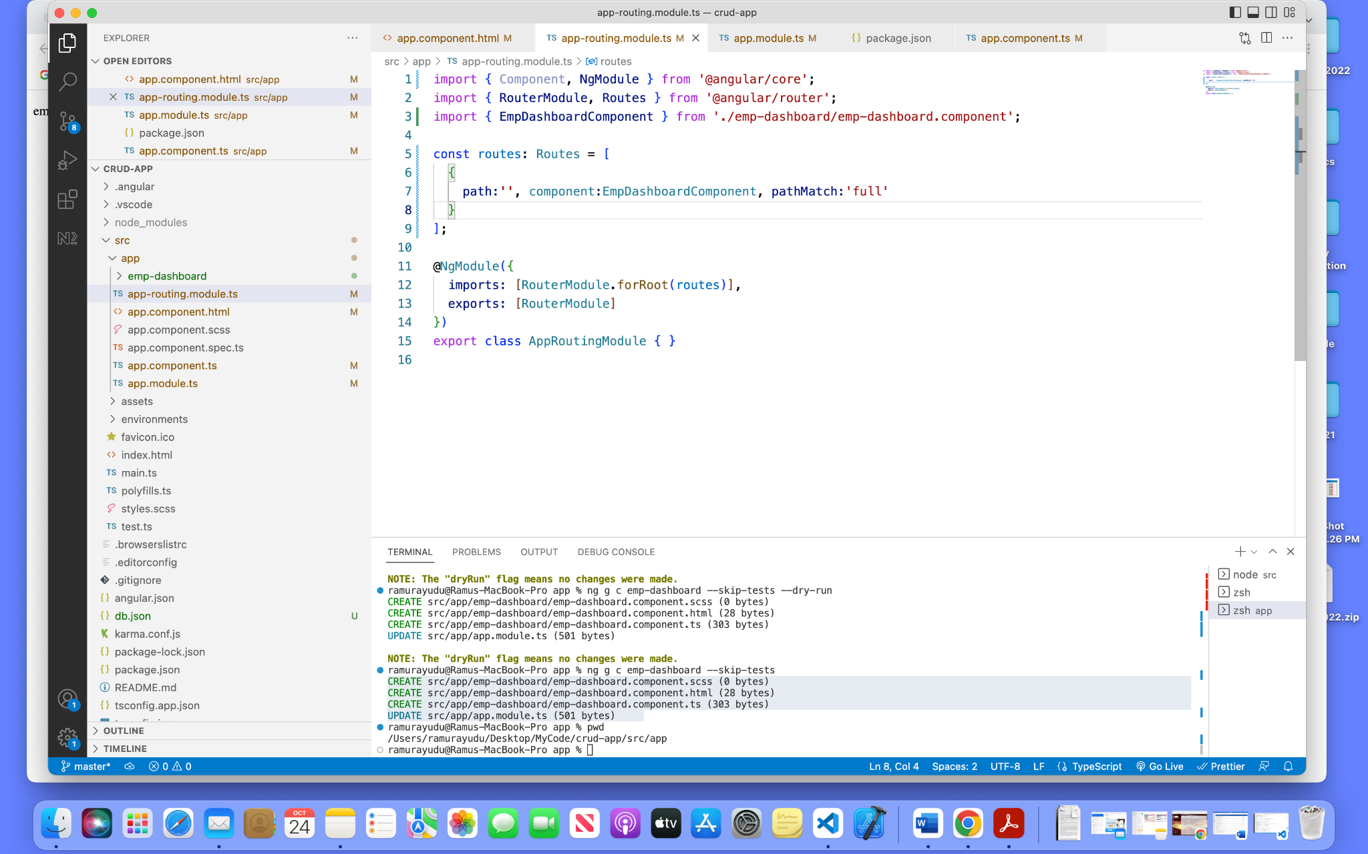

Save the above changes and see the Emp-Dashboard page as default at your local host.

EX: <http://localhost:4200/>

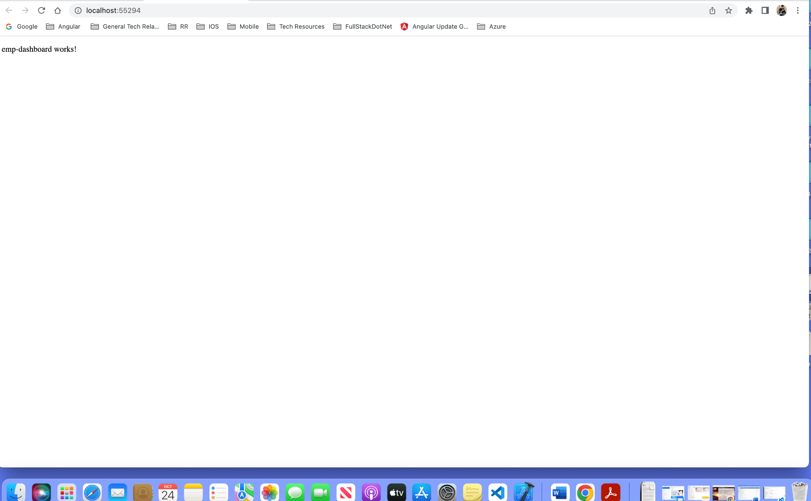

8) Navigate to the emp-dashboard page with route name.

Example: <http://localhost:4200/>emp-dashboard

Create a new route in the Routes array in the app-routing.module.ts as below.

const routes: Routes = [

{

path:'', component:EmpDashboardComponent, pathMatch:'full'

},

{

path:'emp-dashboard', component:EmpDashboardComponent,

pathMatch :'full'

}

];

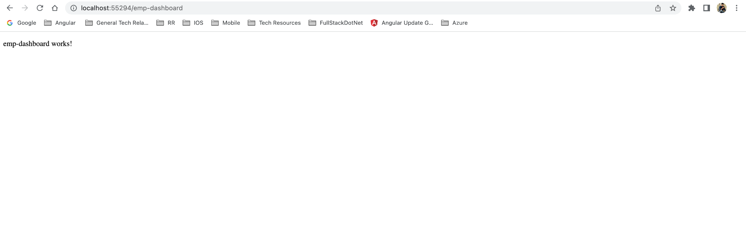

9)Create a Notfound page and display when a user tries to Navigate with the wrong route name.

Create a notfound component and new route for the unmatched route.

**Create Component:**

Run the below command to create a not found component.

**ng generate component not-found –skip-tests**

**Or**

**ng g c not-found –skip-tests**

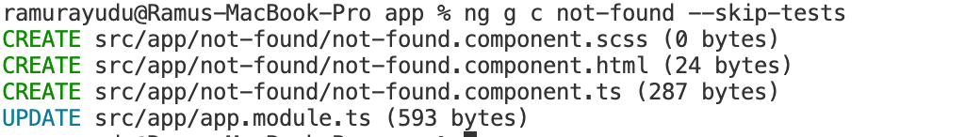

**Create a new route for an unmatched route navigation page.**

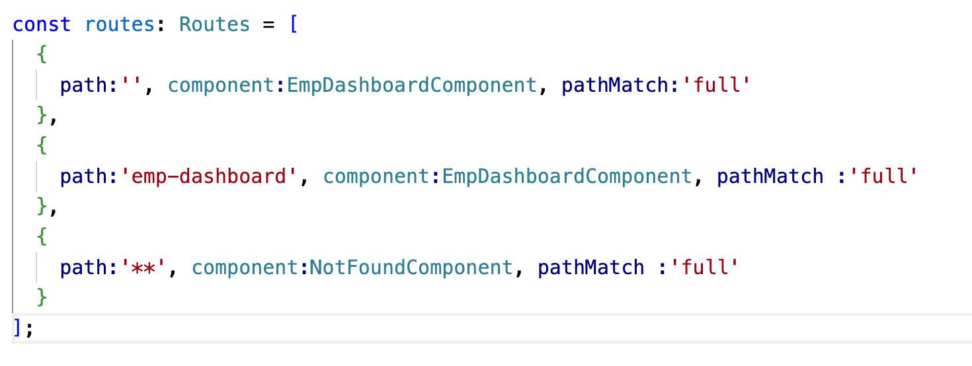

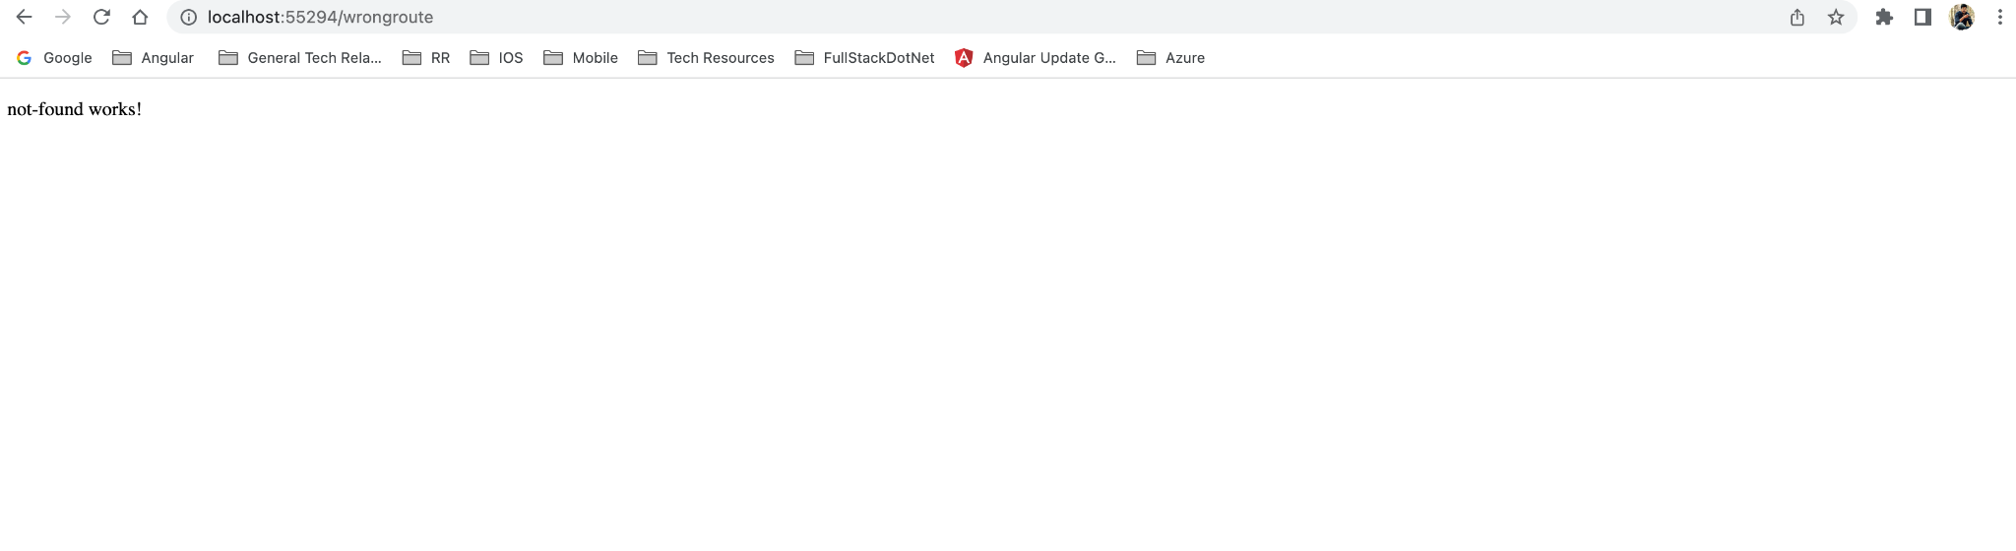

10) Build emp-dashboard UI

Create an employee interface.

**Run commands:**

mkdir shared

cd shared

mkdir interfaces

mkdir shared-service

cd interfaces

Create an employee interface.

Command : ng g class employee —skip-tests



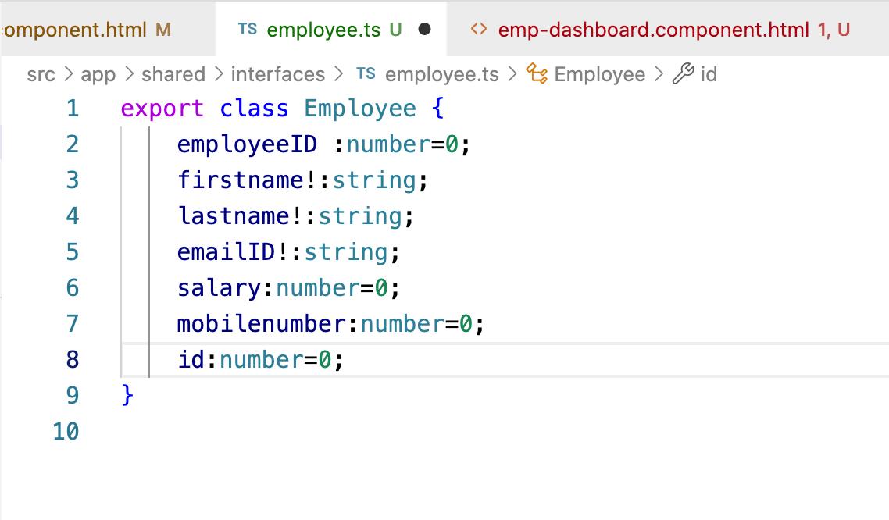

Add employee interface reference and define title of the Grid to use them to create an emp-dashboard view.

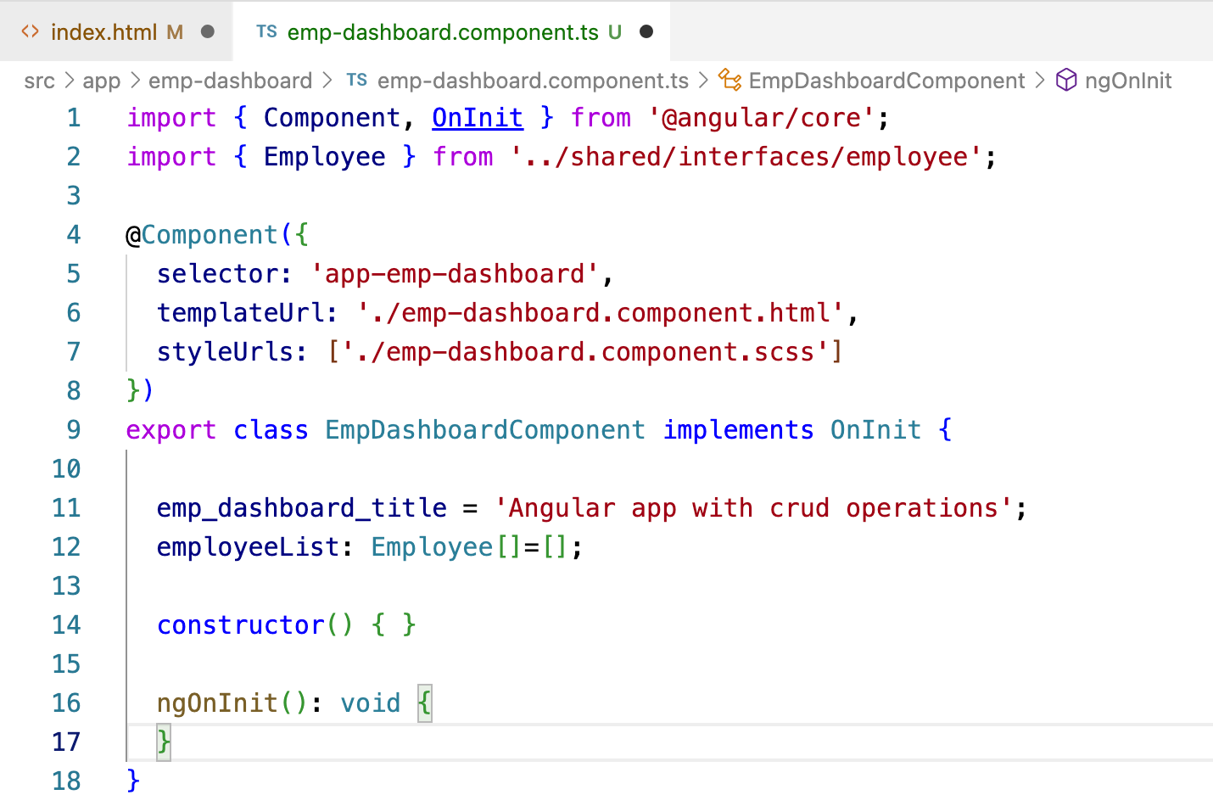

Add below Bootstrap references to index.html to use already defined css and bootstrap modal popup.

<link href="https://cdn.jsdelivr.net/npm/bootstrap@5.1.3/dist/css/bootstrap.min.css"

rel="stylesheet" integrity="sha384-1BmE4kWBq78iYhFldvKuhfTAU6auU8tT94WrHftjDbrCEXSU1oBoqyl2QvZ6jIW3"

crossorigin="anonymous">

<script src="https://cdn.jsdelivr.net/npm/bootstrap@5.1.3/dist/js/bootstrap.bundle.min.js" integrity="sha384-ka7Sk0Gln4gmtz2MlQnikT1wXgYsOg+OMhuP+IlRH9sENBO0LRn5q+8nbTov4+1p" crossorigin="anonymous"></script>

<link rel="stylesheet" href="https://cdn.jsdelivr.net/npm/bootstrap@4.0.0/dist/css/bootstrap.min.css" integrity="sha384-Gn5384xqQ1aoWXA+058RXPxPg6fy4IWvTNh0E263XmFcJlSAwiGgFAW/dAiS6JXm" crossorigin="anonymous">

<script src="https://code.jquery.com/jquery-3.2.1.slim.min.js" integrity="sha384-KJ3o2DKtIkvYIK3UENzmM7KCkRr/rE9/Qpg6aAZGJwFDMVNA/GpGFF93hXpG5KkN" crossorigin="anonymous"></script>

<script src="https://cdn.jsdelivr.net/npm/popper.js@1.12.9/dist/umd/popper.min.js" integrity="sha384-ApNbgh9B+Y1QKtv3Rn7W3mgPxhU9K/ScQsAP7hUibX39j7fakFPskvXusvfa0b4Q" crossorigin="anonymous"></script>

<script src="https://cdn.jsdelivr.net/npm/bootstrap@4.0.0/dist/js/bootstrap.min.js" integrity="sha384-JZR6Spejh4U02d8jOt6vLEHfe/JQGiRRSQQxSfFWpi1MquVdAyjUar5+76PVCmYl" crossorigin="anonymous"></script>

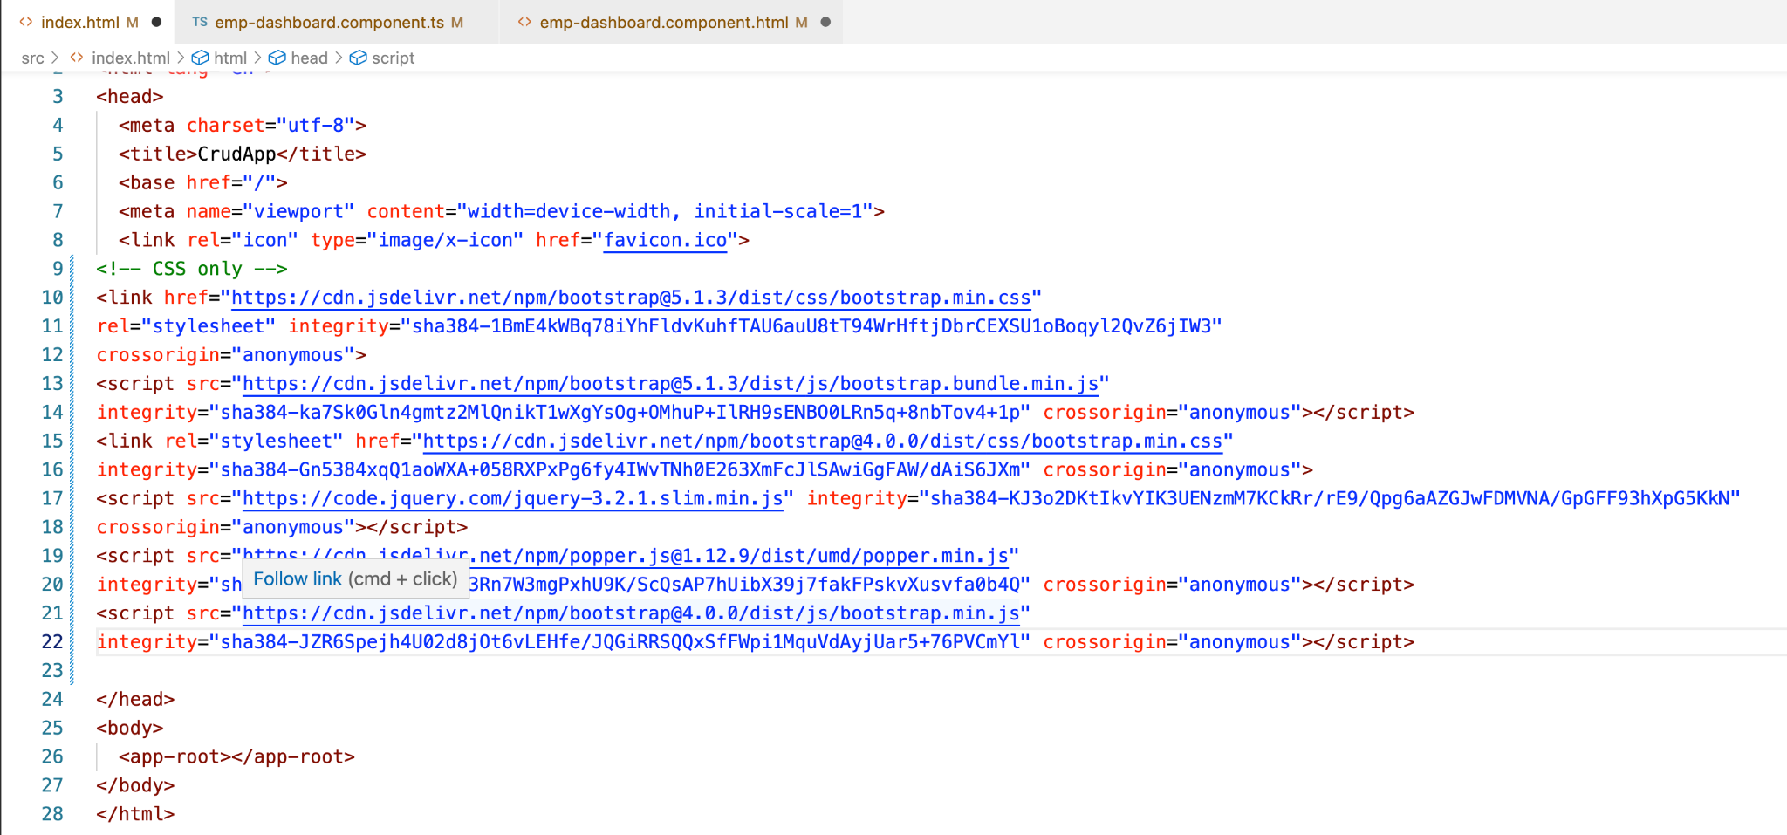

Create a view to display the employee dashboard grid.

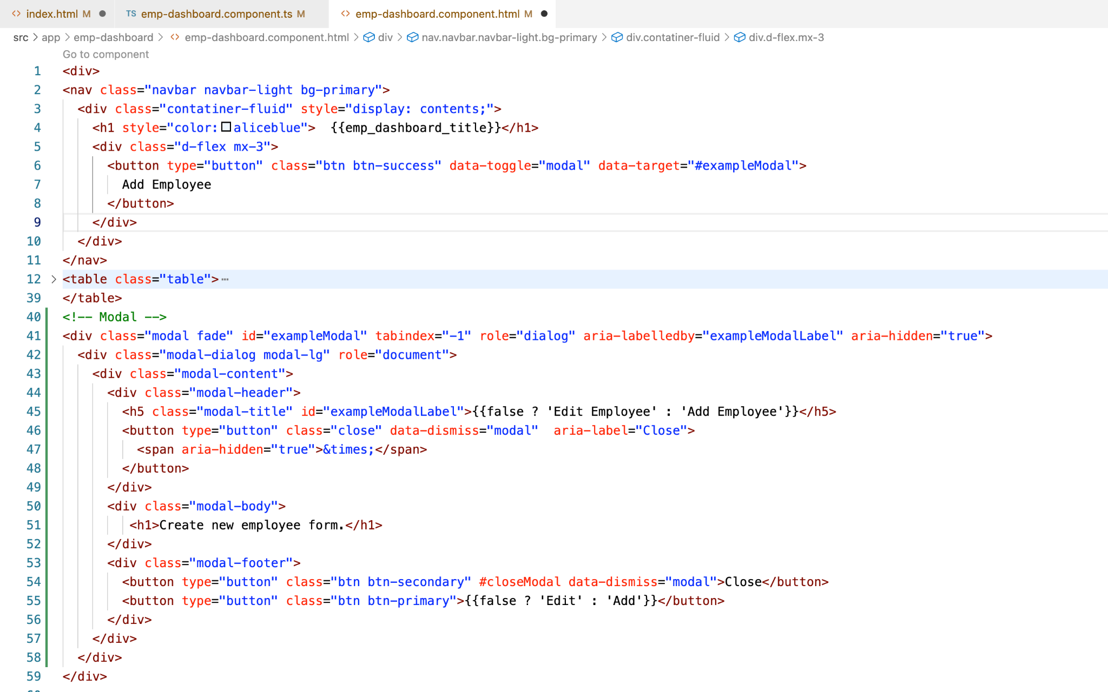

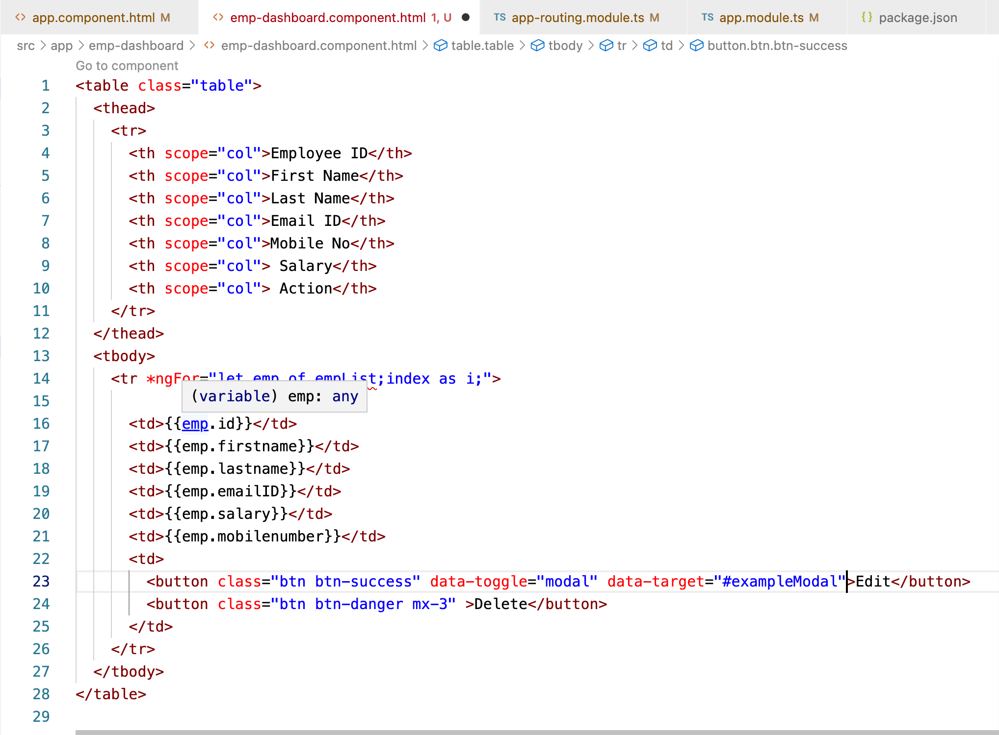

Save the changes and see an empty emp-dashboard grid.

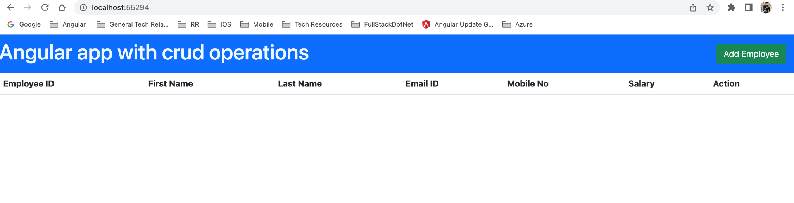

11) Click on Add Employee button to see a modal popup with employee empty form.

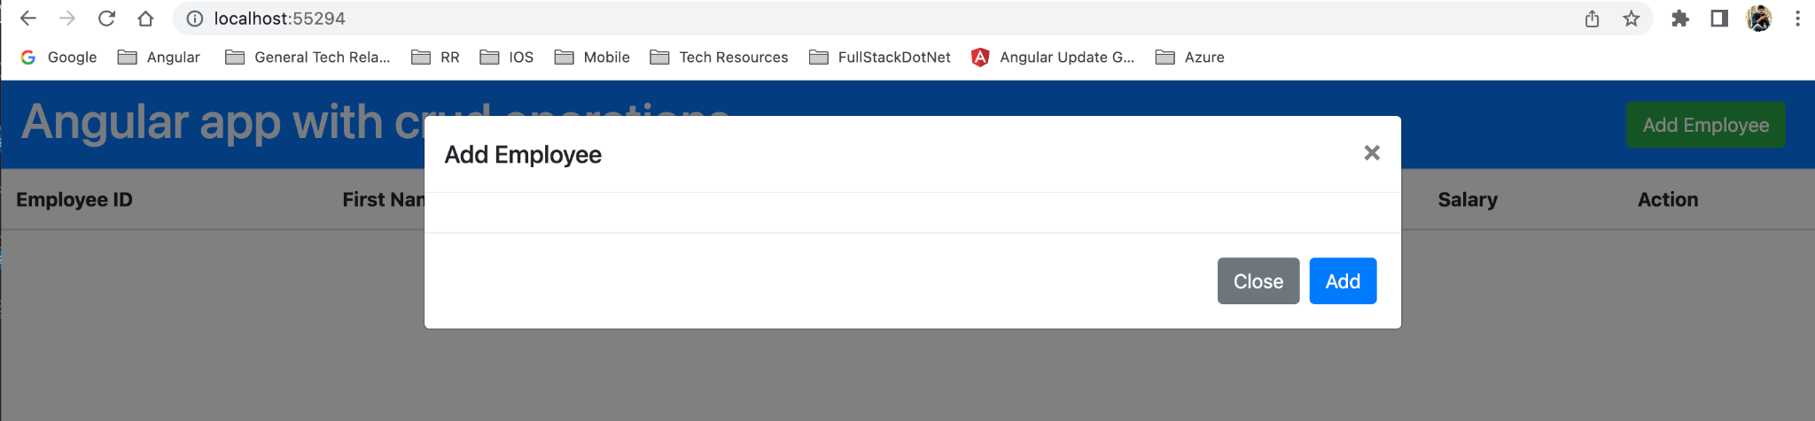

12) Create a new component for add/Edit employee form.

**Run command:** ng g c add-edit-emp --skip-tests

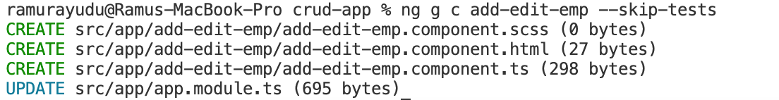

13) Update modal popup body with add-edit.component’s **selector** as a child reference.

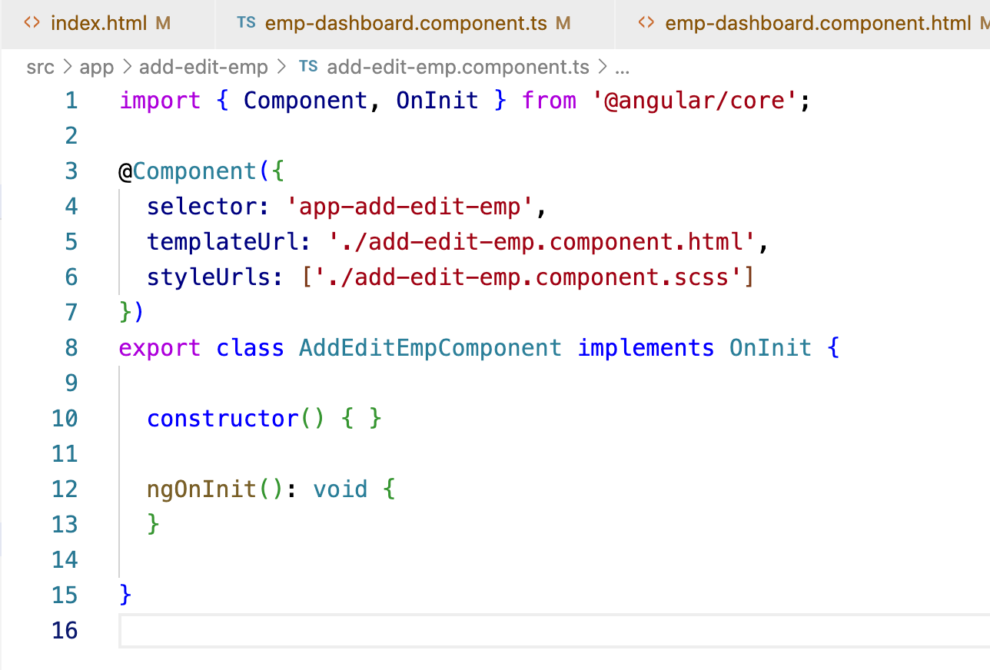

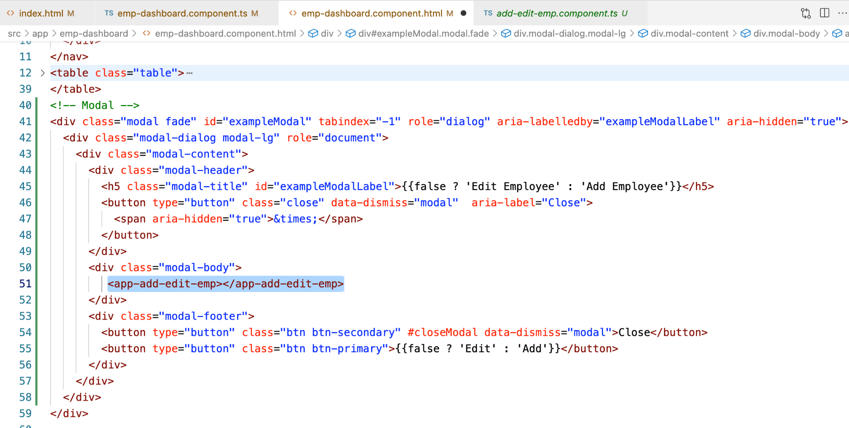

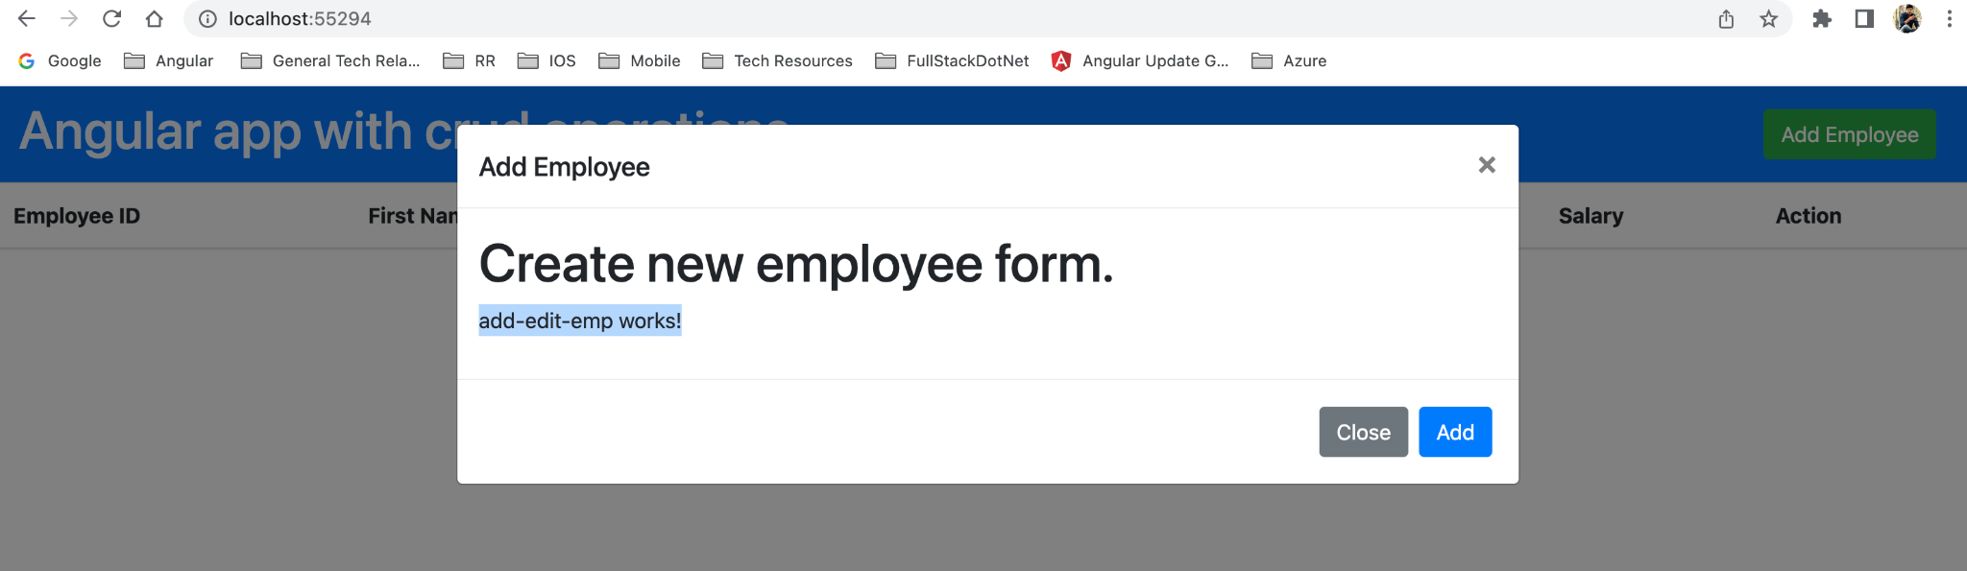

12) Implement Add Employee logic with a new form.

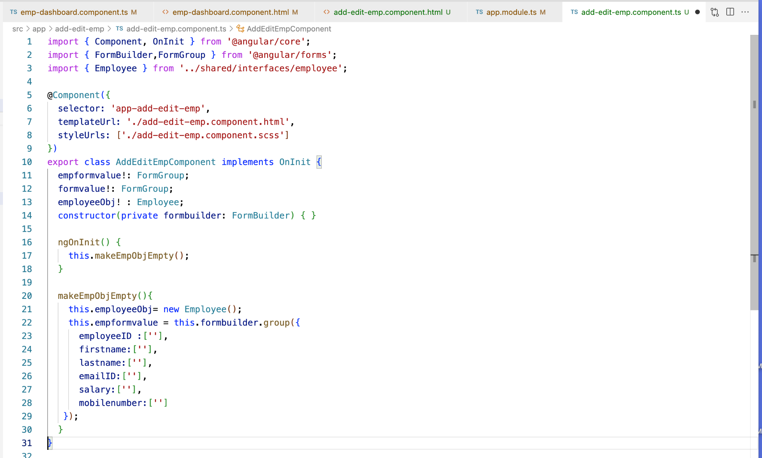

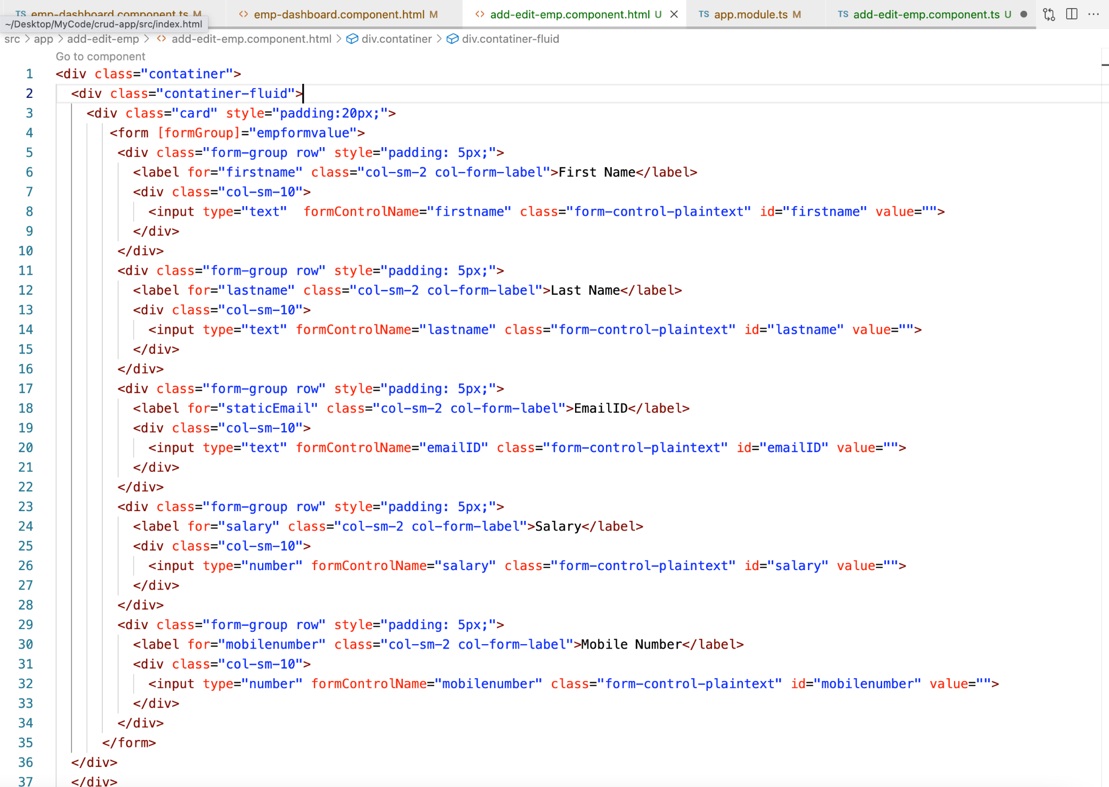

Along with above changes we need to add FormsModule and ReactiveFormsModule to the app.module Imports since we are implementing reactive forms.

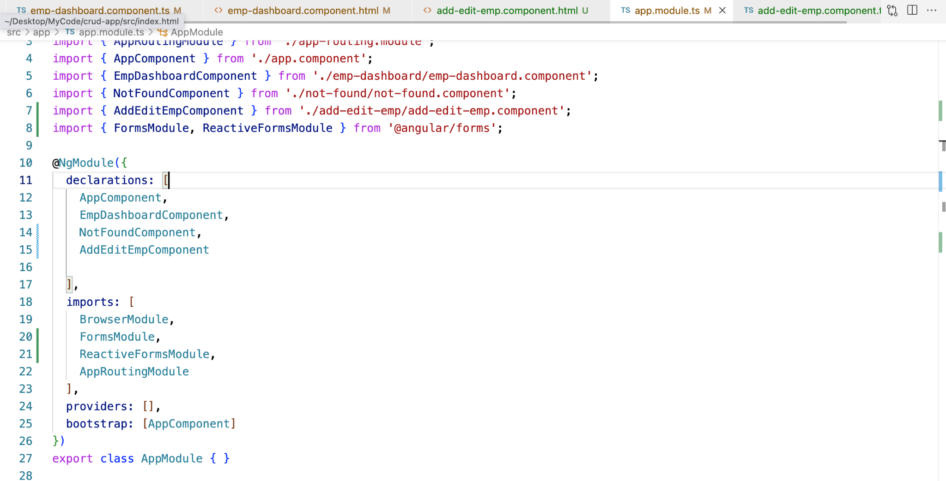

Save all the above changes and see the emp form as below in the modal popup.

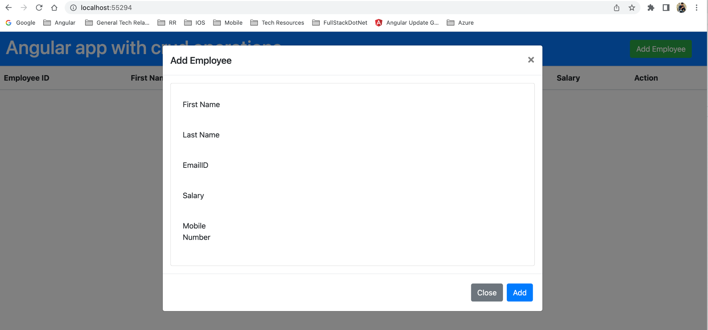

Create a new service which will communicate with Backend service using http client.

**Run Command:**  ng g s empservice —skip-tests



Before adding a new service, import HttpClientModule in the app.module.ts.

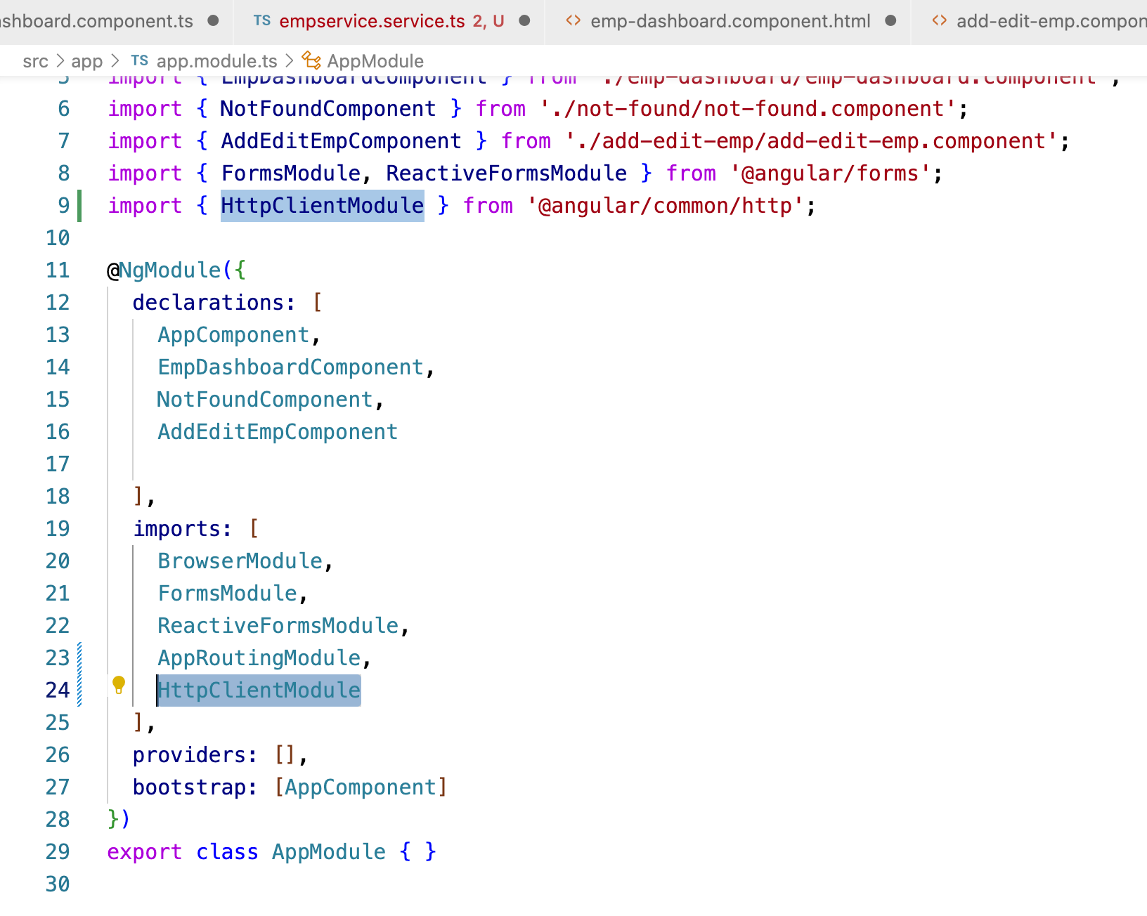

Add logic to the empservice.

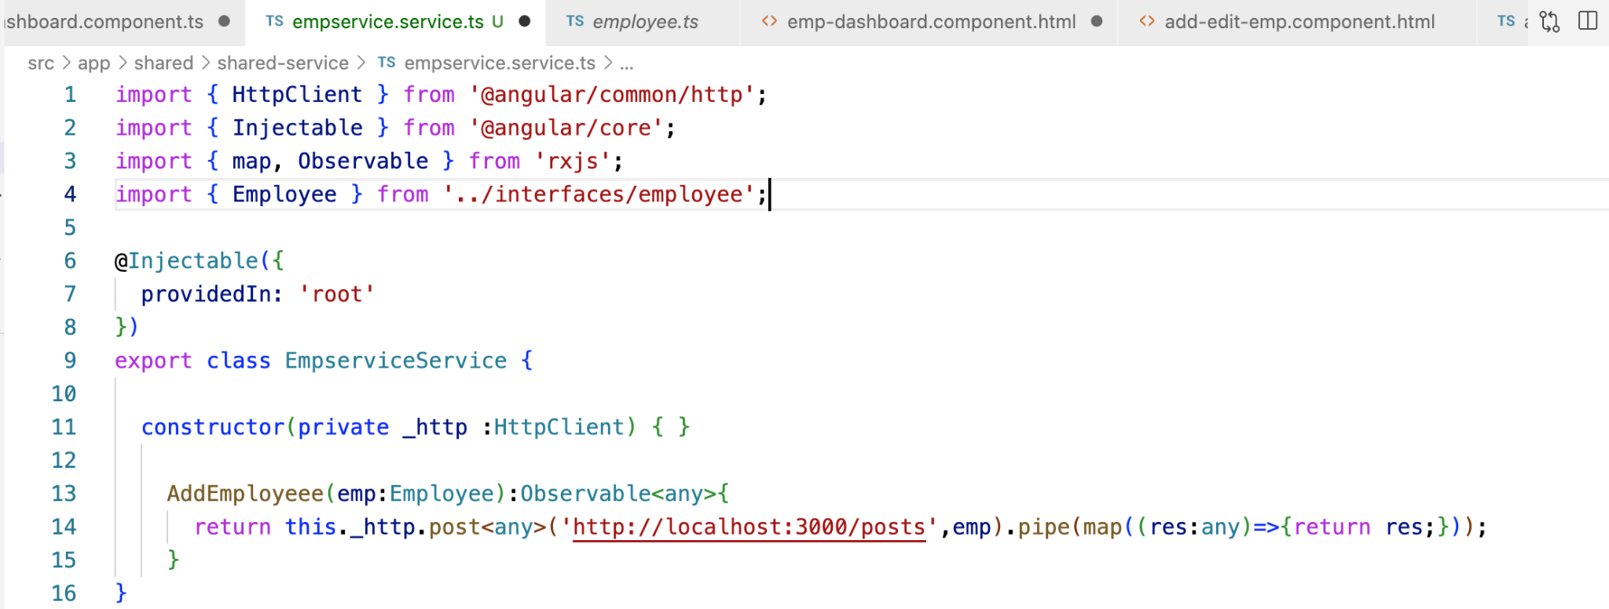

13) Add request logic to hit the endpoint to create a new employee.

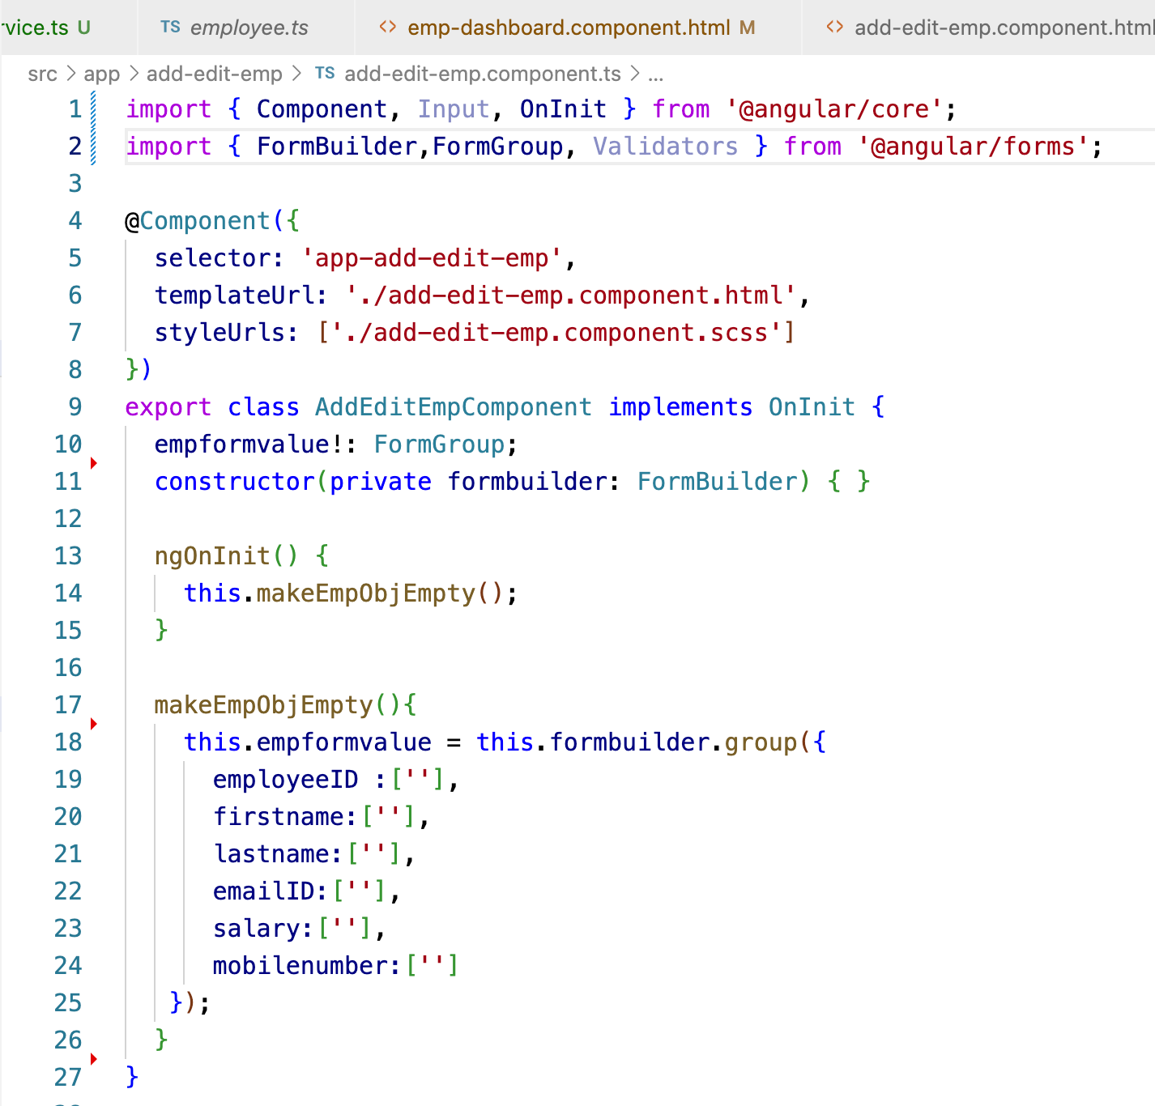

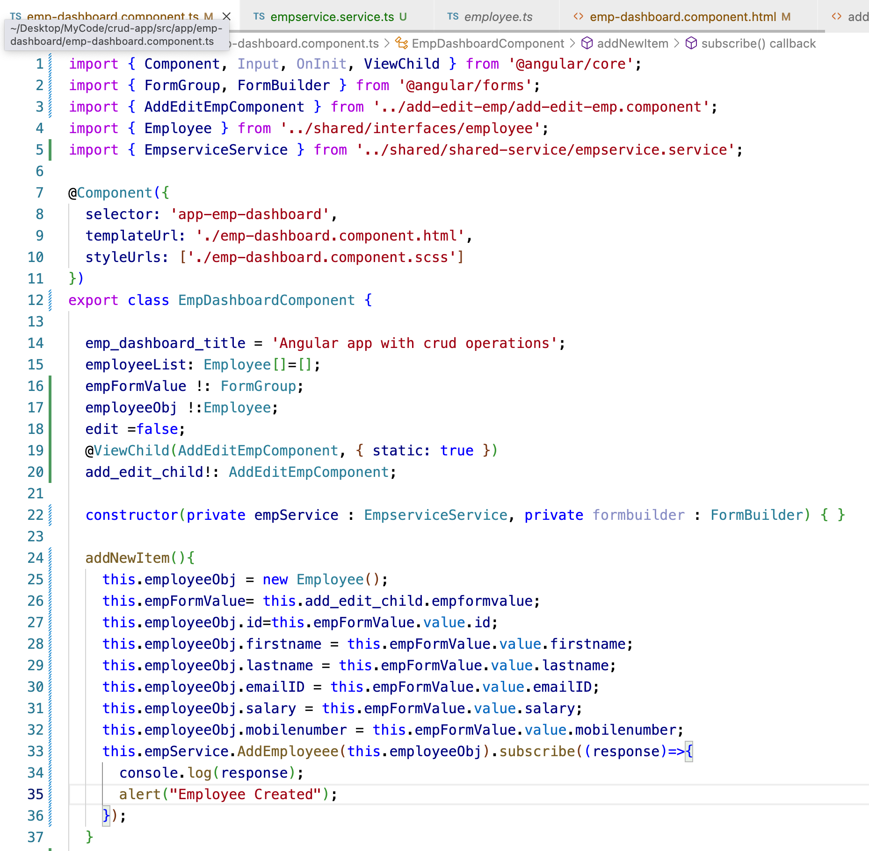

After hitting the add button, the employee gets created in the database and with success response alert popup will be shown as we see below.



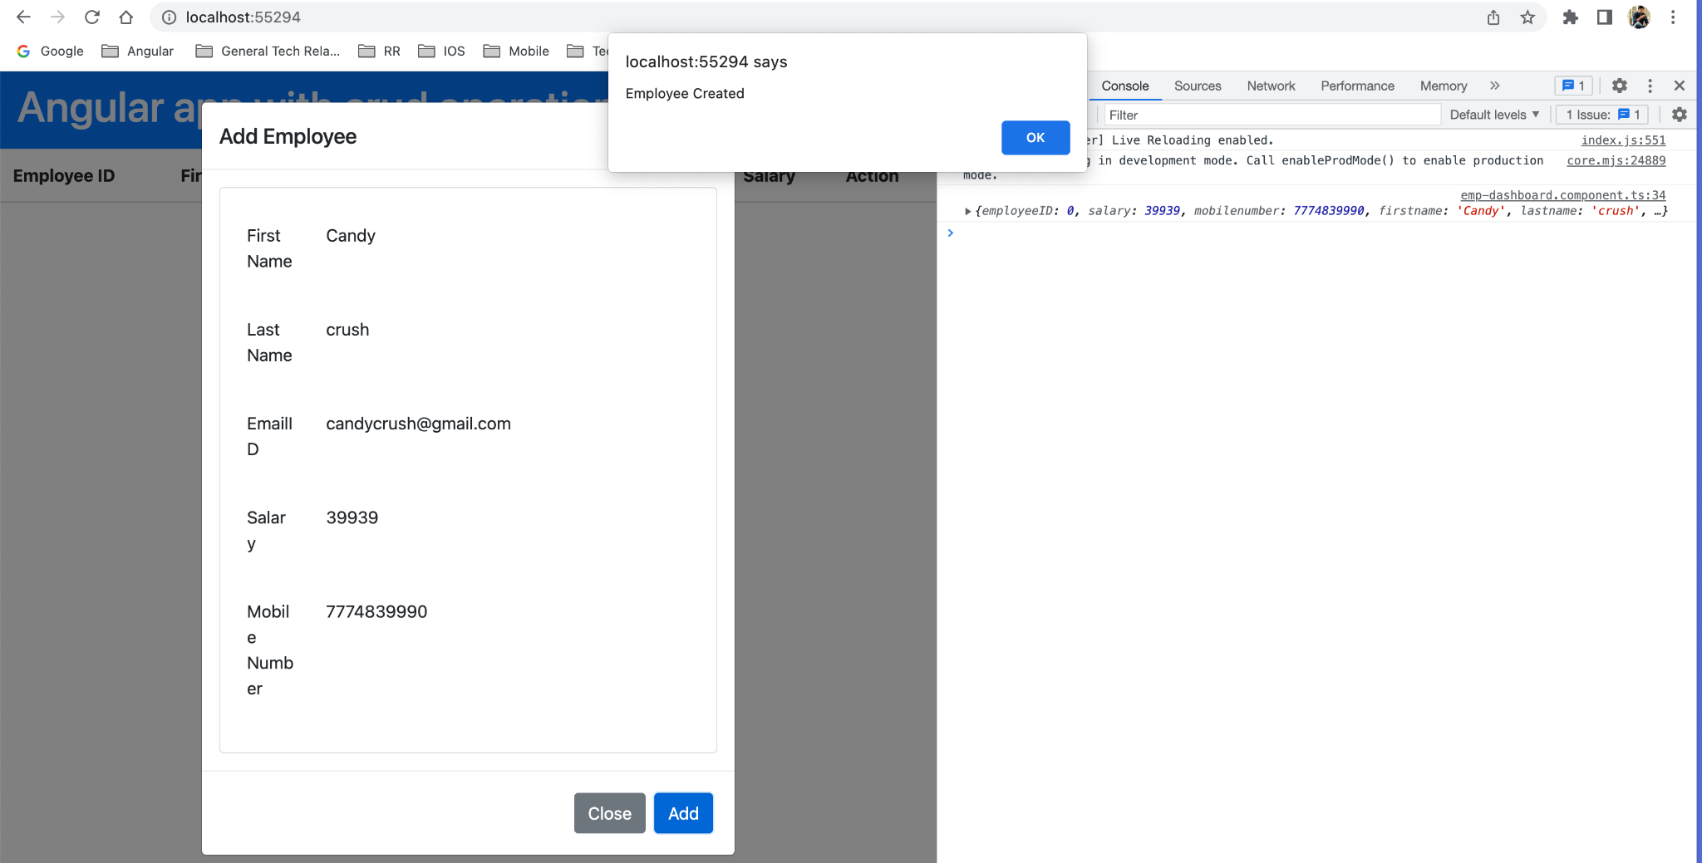

Create a request to display available employees in the employee dashboard grid.

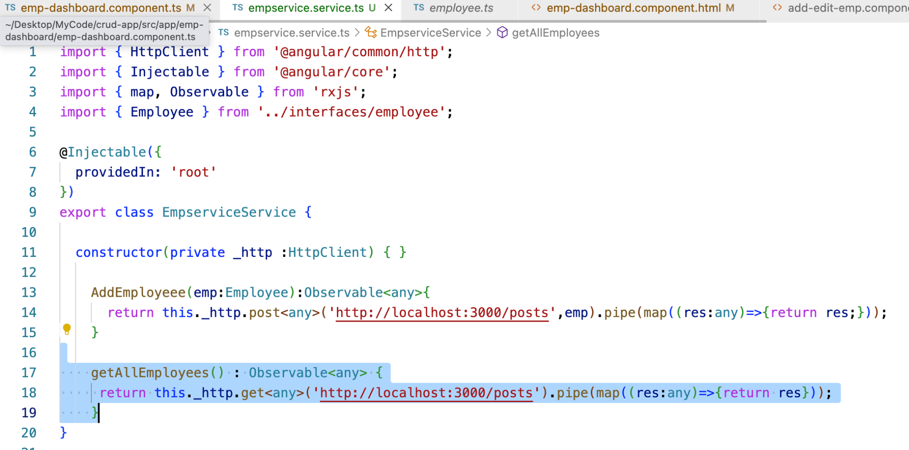

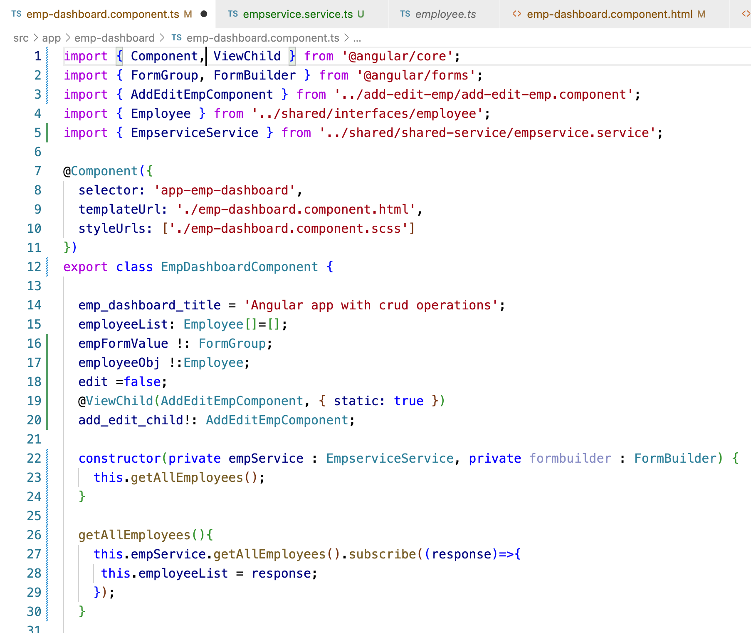

Use the response in the view to display employee information on the UI.

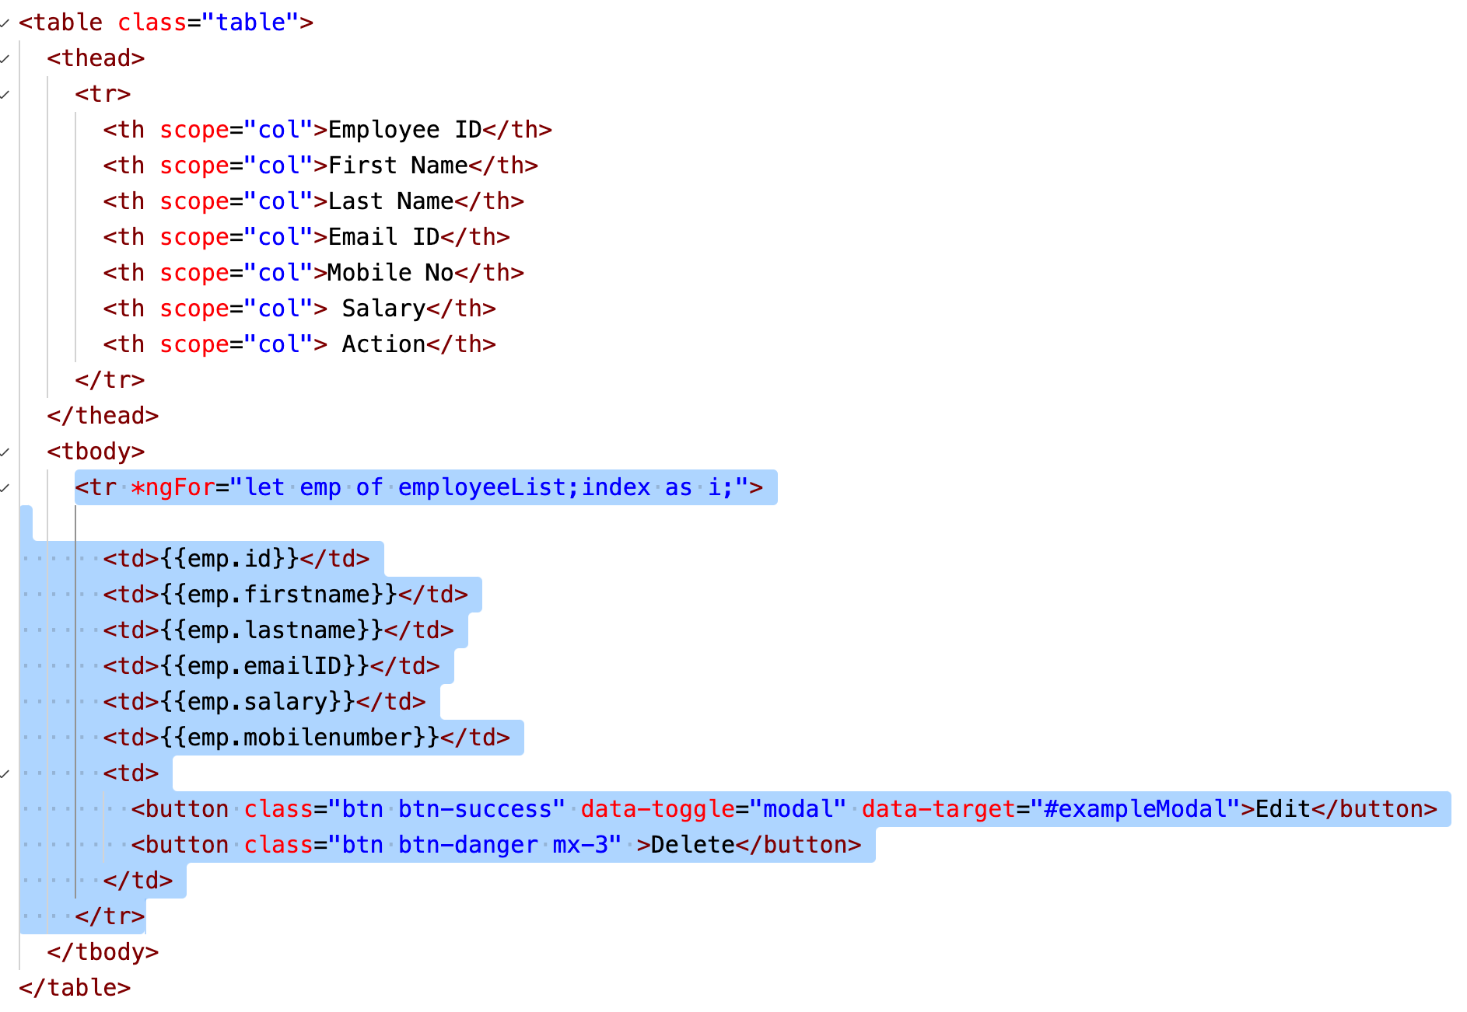

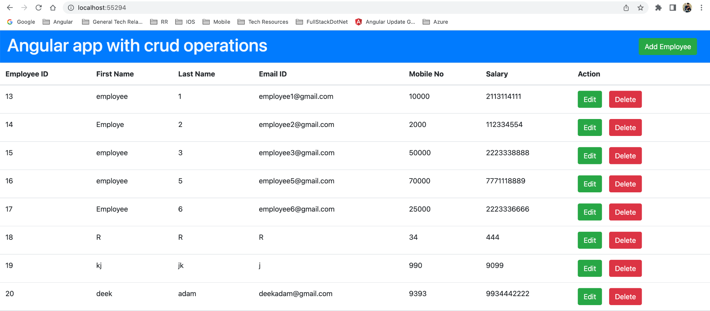

Refreshe the Employee Dashboard grid after adding the new employee.

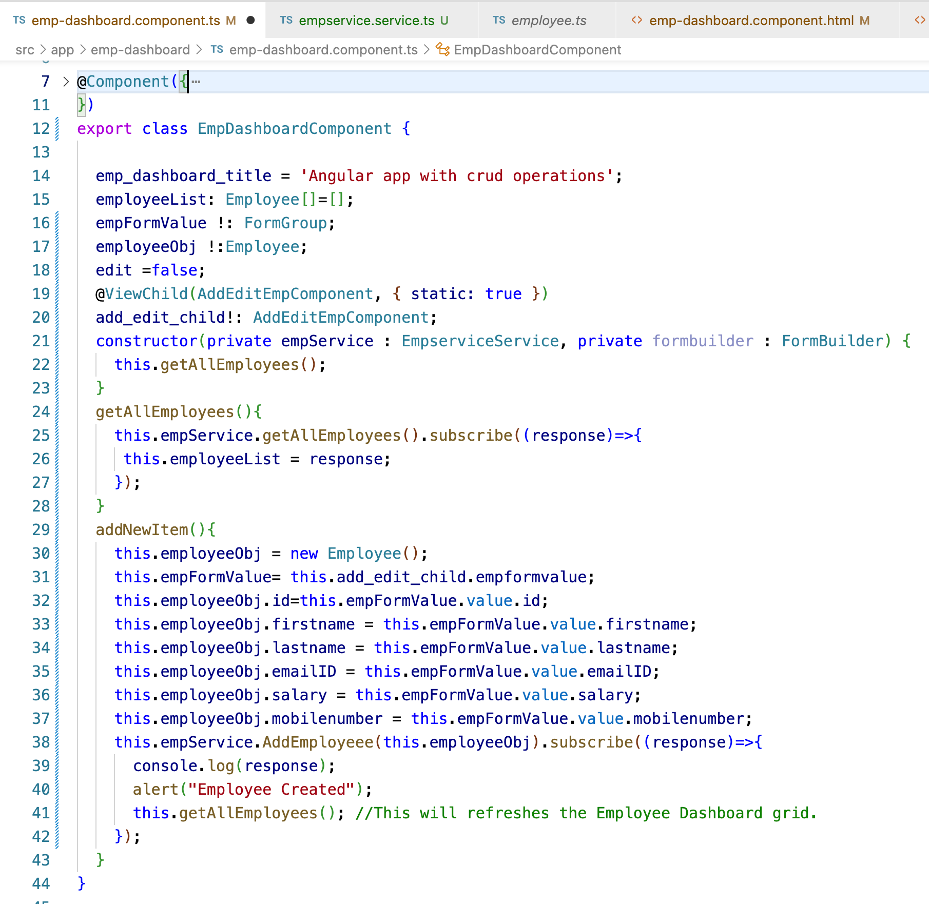

Reset Employee form empty after creating new employee.

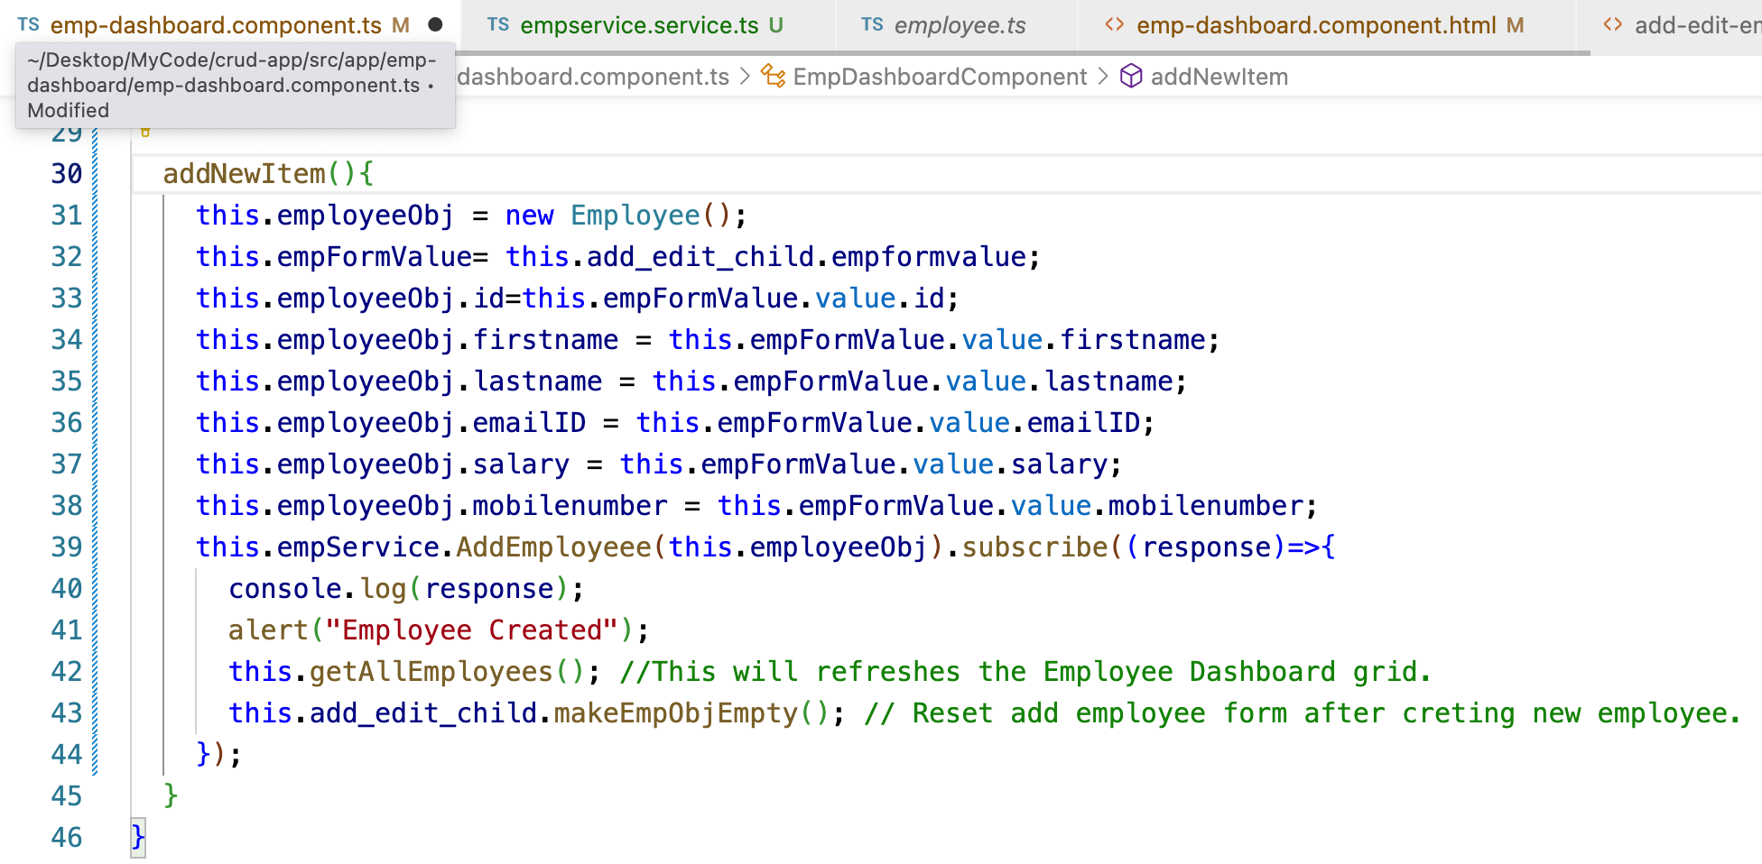

14) Update any employee from the Employee Dashboard.